LAB-3

SUBMITTED BY:D VEERA HARSHA VARDHAN REDDY;210258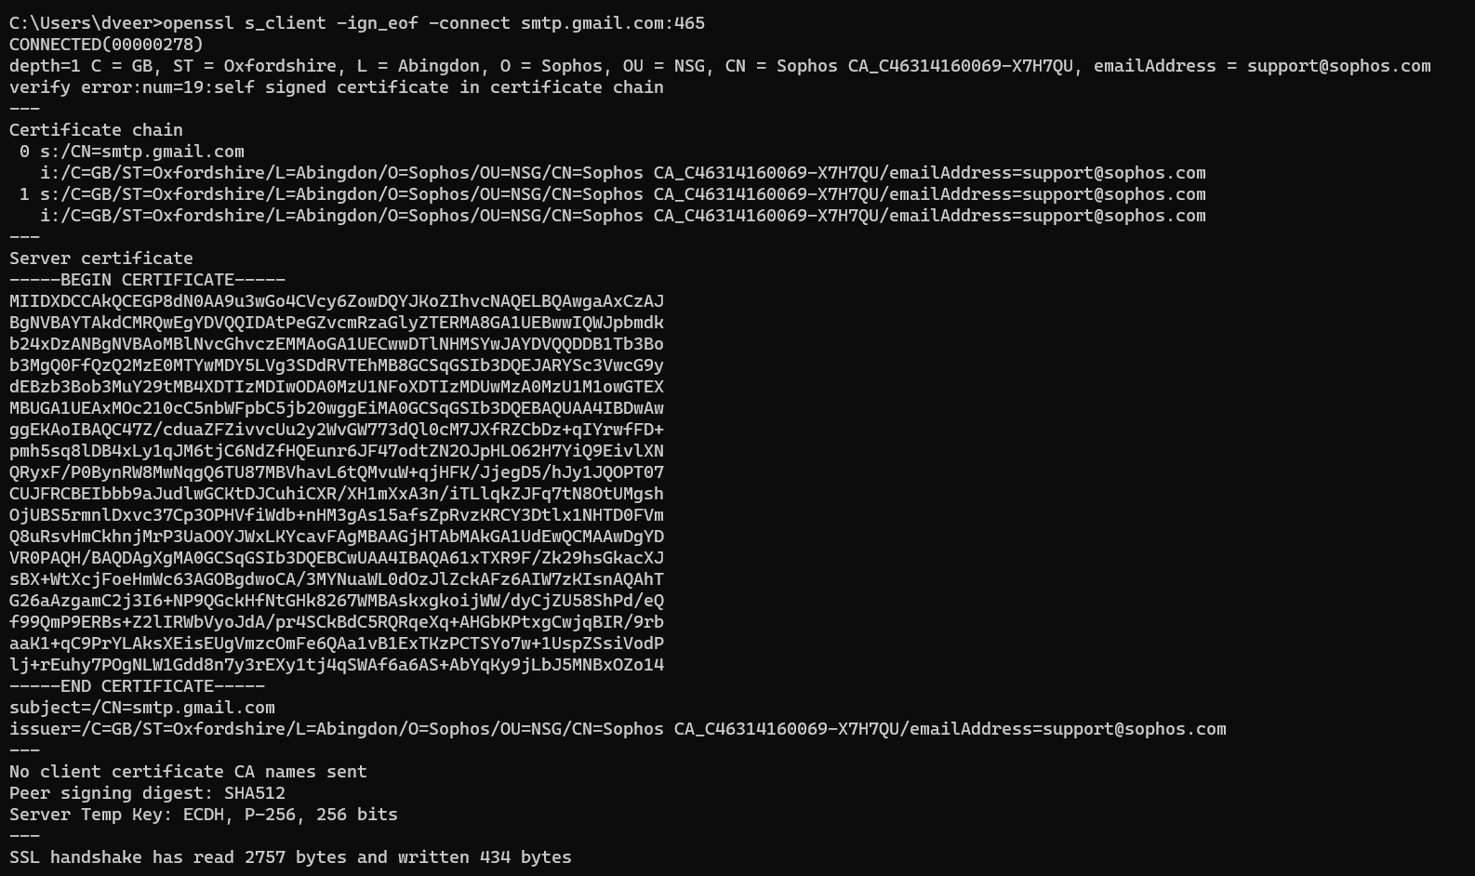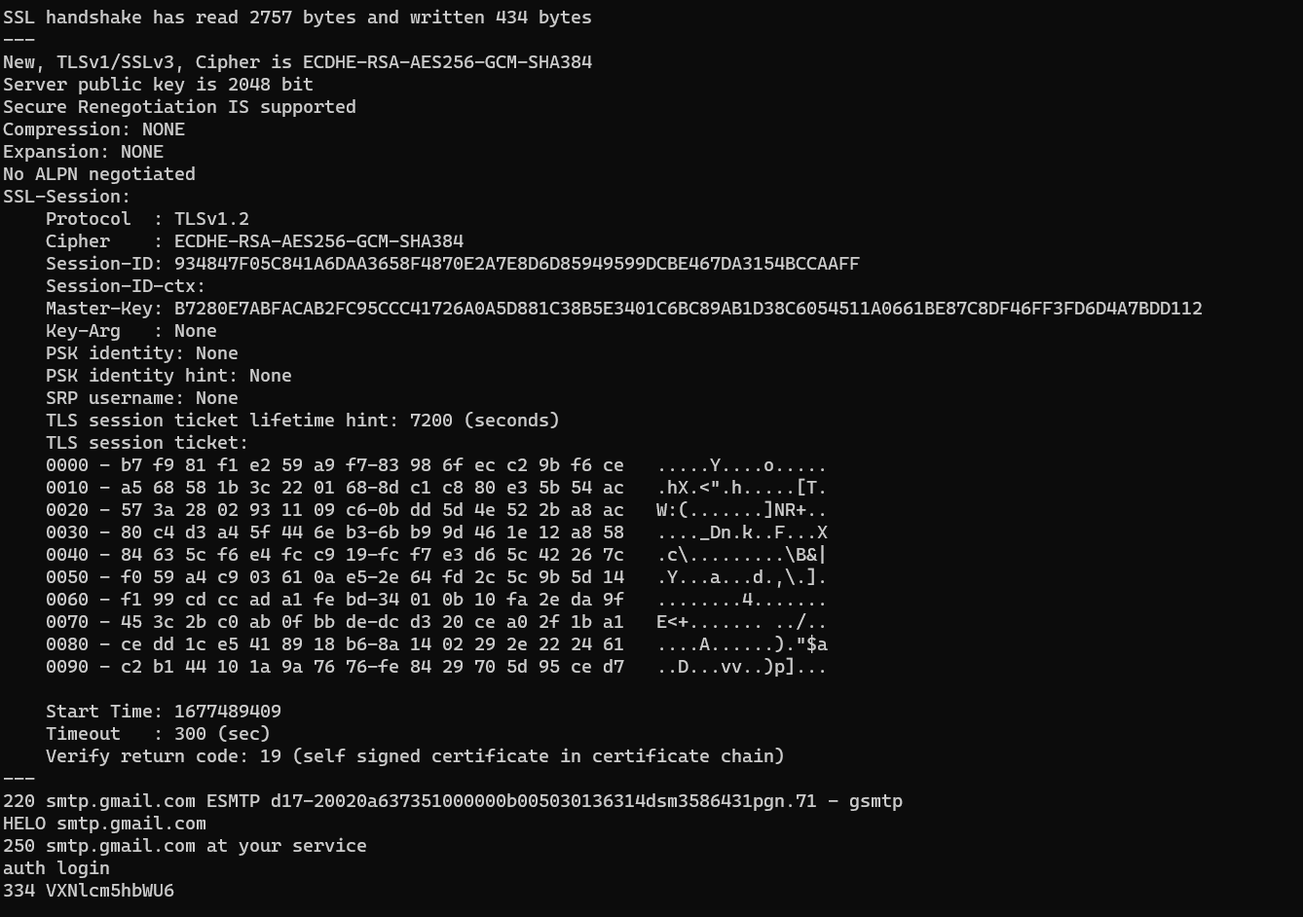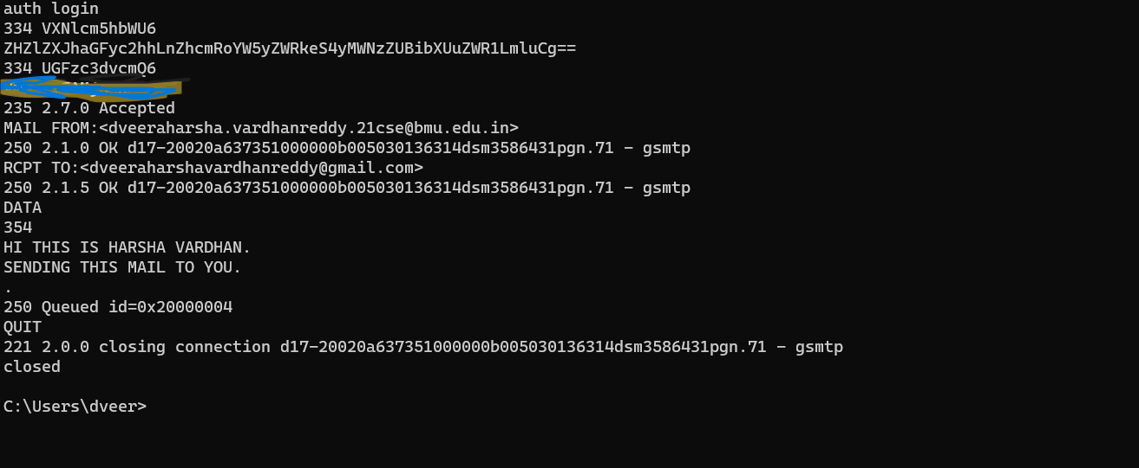

SENT MAIL: 

RECIEVER MAIL: 